- Mass conservation in Operator Splitting
For the sake of simplicity we neglect the diffusion here (or you may assume A as the transport operator= Advection + Diffusion) all the concepts are same also in presence of diffusion.
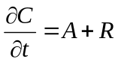
The splitting error is dependent on the commute of the operators [There are two proofs by Leveque, 1981(Fourier Error Analysis) and Lanser, 1999 (lie Operators)].
In time splitting we will have:
- Advection commutes with diffusion if u and K are independent of x
- Diffusion commutes with reaction term in R is linear in C and independent of x
- Advection commutes with reaction if 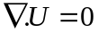and R is independent of x
- With exact integration no splitting error exists if R is linear in c and u, K and R are independent of x.
If the reaction is involved in the process, since it always applies after/before advection, we add or subtract mass (for example see Valocchi 1992, or Leveque 2002), the problem is always exists but it may attenuate with alternating the order of operators, even up to a 2nd order accurate method, that is to say the accuracy is also enhanced with alternating (Strang type splitting) by several order of magnitude.
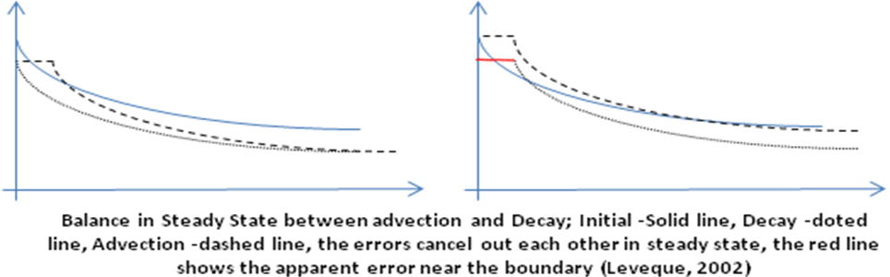
- Kinetically controlled reaction and rapid (instantaneous) reaction in OS
If a reaction is a kinetically controlled it could be modeled by operator splitting, with the rough assumption of adopting the previous time step’s state for the new time, but if a chemical reaction time scale is small (very fast chemical reaction) in compare with other operators’ time scale, the time variable ODE of reaction will become a stiff ODE with a very large reaction rate, lets assume the following equation
MnO₂ 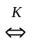 Mn + O₂ (*)
Here it is impossible to solve the following two equations, since the R is mathematically go to infinity or zero:
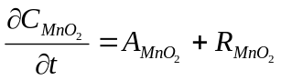
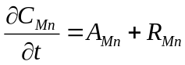
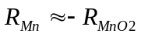
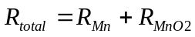
OS has problem when there is fast interaction between constituents, the following approach could be used (here we assumed the dispersion coefficients for MnO₂ and Mn are same and A denotes the transport, diffusion +advection):
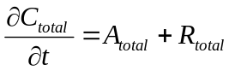
R_{total} = net rate of change in Mn and MnO₂
Then the result C_{total} must divided between Mn and MnO₂ base on another equation; for example K in the (*)
In general the instantaneous interacting constituents could not model by marching on one and then move to another constituent.
My questions:
1- Is it possible to solve just the reaction part simultaneously in implicit method? (Split the matrix at first step and apply transport on both parts, then for solving the R part deal with system of equations?) or it should handled totally in implicit structure?
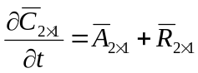
2- How I should quantitatively separate instantaneous and kinetically controlled phenomena? I should find the time scale of the reaction and compare it to the other operators’ time scale?
- Justification of OS for sediment transport problem
There are 10 classes of non-cohesive sediment and 2 classes of cohesive sediment, there is no interaction between non-cohesive classes so the OS could applied on them (several of the non-cohesive ones are bed load, hence they are not treated by ADR equation). The 2 cohesive classes have interaction with each other and their interaction governed by turbulence and other factors, they assumed to be in equilibrium condition.
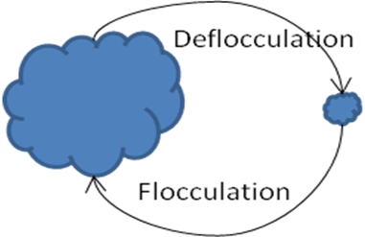
The here question is the above cycle is equilibrium in compare to hydrodynamics time scale or it can assumed kinetically controlled?
Advection acts similarly for entire suspended constituent (at least in our framework we assume it to be same), if the longitudinal dispersion assumed to be identical for large and small cohesive sediments (the formula is not depends on the particle size) [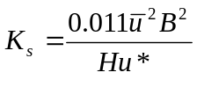 where u is average velocity, B is the channel width, H is depth and u* is shear velocity (Abbott, 1993)] so we might solve the ADR for all cohesive sediment and at the end divide the resultant into two classes base on the turbulence, salinity, PH, etc.

Population balance modeling, interaction between size classes, is kinetic

